Sharlene is the author of Blind Devotion: Survival on the Frontlines of Post-Traumatic Stress Disorder and Addiction. She has a Bachelor’s Degree in Comprehensive Social Studies and Secondary Education from the University of Wisconsin-Eau Claire and a Master’s Degree in Teaching and Learning from St. Mary’s University in Minnesota. She has been teaching High School Spanish for seventeen years, and is also certified to teach Psychology, Sociology, History, and Political Science.

**Sean served in the Army’s 10th Mountain Division from 1994-2000. He was deployed to Bosnia with the NATA S-FOR Peacekeeping Force in 1999. He was an E-5 sergeant, a team leader, and a guest instructor at West Point Military Academy.

**Due to Sean’s PTSD and anxiety, which is unpredictable, we cannot give a 100% guarantee that he will be present at any given workshop. However, even on the rare occasions when he cannot share in person, his perspective and ideas are always folded into Sharlene’s presentation.

**Neither Sharlene nor Sean has a degree in any area of mental health care. Their “expertise” is purely from experience and personal research. Both are certified suicide prevention QPR Gatekeepers.

Author, Sharlene Prinsen Army veteran, Sean Knapp

Journey of a Family in Crisis

Family and Professional Workshop Series

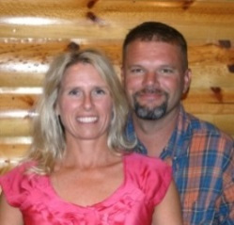

Fees:
1 hour workshop: $125* + transportation
2 hour workshop: $200* + transportation
½ day (4 hrs total): $350* + transportation
Full day (6 hours total): $500* + transportation

*For travel more than 150 miles, we may request an additional allowance for lodging.

“I can't find the words to adequately express how powerful your presentation was today. You and Sean did a great job today sitting side by side telling a group of strangers the very intimate details of your life. What courage you both have!”
--Sheri Norgard, Mental Health Task Force of Polk County; CESA 11 Headstart Coordinator

“Your work on this is phenomenal. I have provided education on issues of codependency for years. Hearing this presentation and reading this book has enhanced my practice and given me a more intimate understanding of the complex needs of families in crisis.”
--Sharon Ward, MA, licensed psychologist

After a decade of living with PTSD – a journey which included depression, alcoholism/addiction, abuse, suicide attempts, incarcerations, and five stints in treatment -- Sharlene and Sean were broke, hopeless, and on the verge of divorce.

Today, they are embracing recovery and finding peace despite their ongoing challenges. These workshops offer a unique, intimate look inside the shadows of mental illness, as Sharlene and Sean share with unprecedented brutal honesty about the chaos, heartache, and despair that a family in crisis experiences.

Journey of a Family in Crisis workshops offer hope, encouragement, and information to individuals and families affected by mental illness. For professionals, they offer “insider” experiences and intimate insights that can never be learned through textbooks or classroom training.

Published by Hazelden Publishing

Sharlene Prinsen
2365 201st Avenue
Saint Croix, Falls, WI 54024
715-557-0312
sharleneprinsen@gmail.com

Hope and Healing for Peace and Purpose
www.facebook.com/SharlenePrinsen/RecoverySupport
Offering information, hope, and encouragement to individuals and families in crisis, and unique insights and resources for the professionals who serve them.
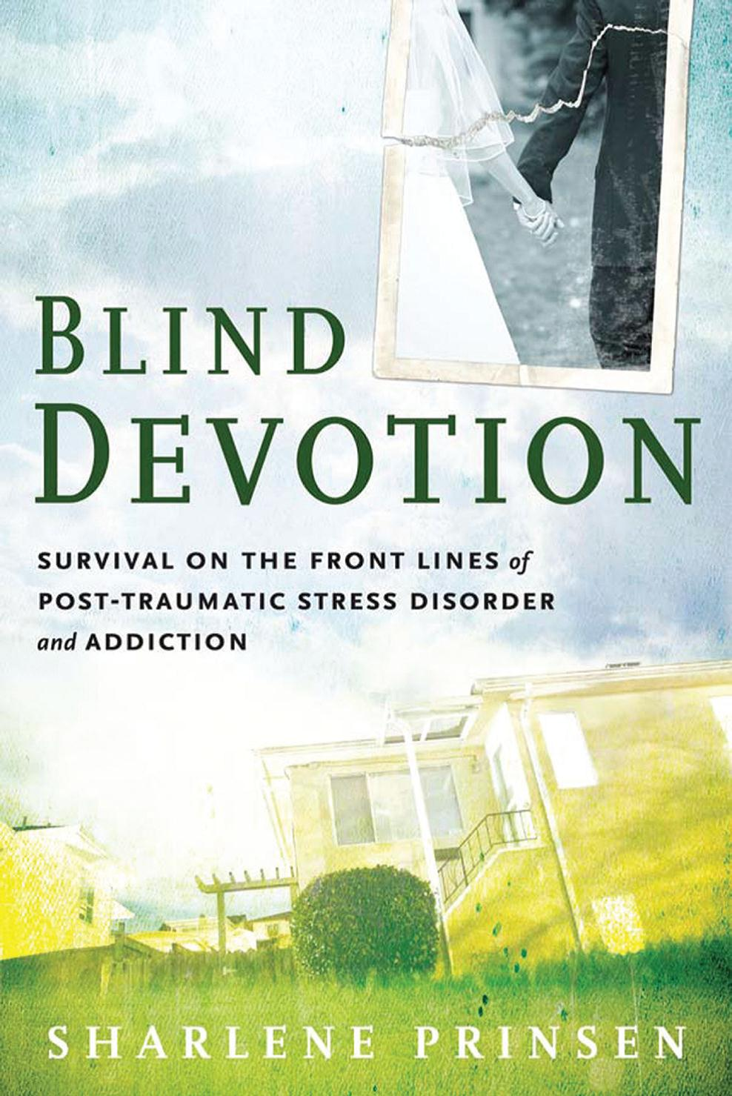

Please see fees and contact information on the back of this brochure.
OTHER:
If you have another idea for a workshop, or if you have a slightly different need and would like us to adapt one of these workshops to better fit your purpose and audience, please feel free to talk
with us about it.
Marriage and PTSD:

PTSD can suck the joy and romance out of a marriage, turning friends and lovers into “roommates” at best, and enemies at worst. This special workshop is designed for married couples who want to heal the hurts that PTSD brought into their lives, improve communication to better cope with PTSD challenges, return laughter to the relationship, and rekindle romance.

1 hour workshop

For individuals and loved ones (veteran or civilian) affected by mental illness:

***For more general audiences, we offer an adapted version of all of the workshops listed under the section entitled “For Veterans and Loved Ones.” For these workshops, there is a recognition and acknowledgment that the audience is far more diverse and that the trauma experienced by participants may stem from a wide range of sources, not just military or combat situations.

For Veterans and

Loved ones

Heroes in Crisis: Moving From “Hell” to “Healing”

Three huge needs of individuals or families experiencing crisis are: 1) the need to understand, “What’s going on?” 2) the need to know, “I’m not alone,” and 3) the need to believe, “There is still hope.” This interactive workshop addresses each of those needs from the heart of a family who has “been there.” Veterans and loved ones will get an overview of PTSD, depression, and addiction that goes beyond a mere list of symptoms (ie. “limited range of emotions,” “hyper-vigilance,” “neglect of self-care”) to explain in compelling detail how these elements really look in daily life and, more importantly, how they impact seemingly unrelated issues within the family dynamic. An unprecedented brutally honest look inside the inner workings and destructive thought patterns of a family in crisis, providing unique insights that may help families that are “stuck” find the keys to moving themselves forward in recovery. This is an interactive workshop that encourages a Question and Answer format throughout. Veterans and loved ones will gain a better understanding of PTSD, depression, and addiction, as well as a wealth of resources and practical tips to cope with these illnesses and to improve family life – ideas gained from a decade of experience living with PTSD.

2 hour workshop

Lessons of Recovery: Learning to Find Peace in the Pain

Chronic PTSD and depression are life-long challenges that require a change in the perspectives, attitudes, beliefs, and thinking patterns of all members of the family system. In this interactive workshop, participants will learn how some of the lessons and principles normally gained through Twelve-Step addiction programs can be equally successful in helping individuals and families affected by other mental illnesses find a sense of peace and purpose, even in the midst of life’s storms.

1 hour workshop

For Professionals:
Families in Crisis: An Intimate Portrayal of Untreated Mental Illness

This workshop examines five key stages that a family in crisis may experience, going beyond a textbook lists of symptoms (“neglect of self-care,” “regressive behavior in children,” “limited range of affect,” etc.) to explain how these elements really look in daily life, and, more importantly, how they impact seemingly unrelated issues within the family dynamic. An unprecedented brutally honest look inside the inner workings and destructive thought patterns of a family in crisis, providing unique insights that may help identify the barriers for families that are “stuck” and reveal the keys to moving them forward in recovery. This is an interactive presentation that encourages a Question and Answer format throughout. We are committed to giving honest answers, even when it exposes our continued struggles or mistakes, in order to help professionals gain a full understanding of the attitudes, beliefs, fears, and motivations that keep a family system “stuck” in chaos.

2 hour workshop

Families in Crisis: Resource Ideas to Better Serve Families in Need

This is an “add-on” to the presentation described above. It offers a comprehensive discussion of resources, services, or approaches that can enhance or hasten recovery for families affected by mental illness. Many of these ideas can be implemented by individual mental health care professionals in their own practice. Others may require a collaborative effort of several professionals or organizations. All of them are valuable suggestions from a family who has worked hard to identify “what worked,” “what didn’t work,” and most importantly, “what resources we wish we had been offered.”

1 hour “add-on” workshop

For information on open positions or to submit your resume, please visit our Web site at: www.lucernepublishing.com

